Central Kitsap School District
Montessori Application

Student Name
Entering Grade Level

Student’s Date of Birth
Boy
Girl

Current School
Dates

Montessori? Yes
No
Total Years of Montessori Experience

Sibling Enrolled in CKSD Montessori? Yes
No
Name of Sibling

Resides in CK School District: Yes
No

If yes, which CK neighborhood school

In no, which school district do you reside in?

If you reside outside of the CK boundary and your child is accepted into the program, you will need to complete release/transfer papers, and re-apply each school year.

Parent/Guardian Names

Mother Mailing Address

City
State
Zip Code

Home Phone:
Work/Cell Phone:

Email:

Father
Mailing Address

City
State
Zip Code

Home Phone:
Work/Cell Phone:

Email:

Guardian
Mailing Address

City
State
Zip Code

Home Phone:
Work/Cell Phone:

Email:

Date Attended Information Night:
or Date of Classroom Visit:

Attendance at a Parent Information Night is highly recommended.

Please provide written responses to each of the following statements/questions.

1. Why do you choose a Montessori education for your child?

2. Has your child participated in other Central Kitsap School District special programs?

No Yes (if yes, please describe below):

3. What other information would you like to share about your child and placement in this program?

Please mail to: Hawk Elementary at Jackson Park
Attention: Diane Yetter
2900 Austin Drive
Bremerton, WA 98312

Application is due by March 25th.
You will be notified by mail by the end of April of the placement of your student in the program.

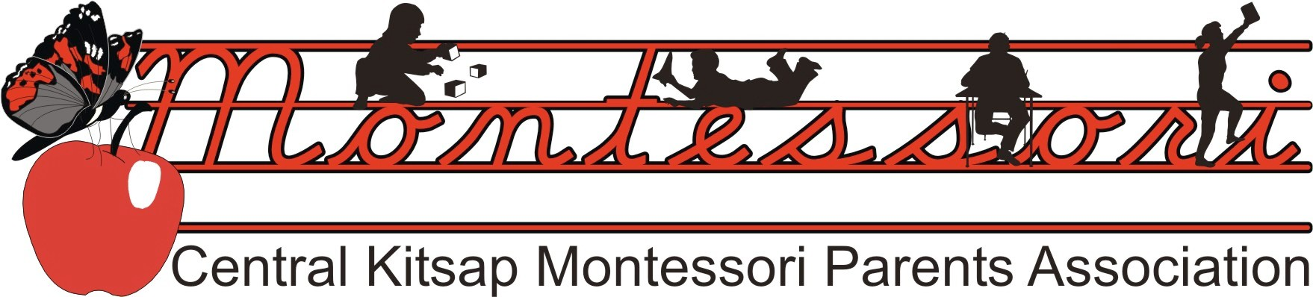

Montessori Program Parent Responsibility & Confidentiality Commitment

Student name(s) and grade(s) Parent name(s) Mailing address Neighborhood school Phone number(s) of parent(s) Email address
 Please check here if you do not want your information published in our CKMPA Contact List.

Time Commitment: One of the purposes of the Montessori program is to make learning a positive experience and foster independence for lifelong learning. Parent involvement with the Montessori classroom is a key program element. Parents are adult role models and are important in assisting to develop the prepared environment. In working together, more time can be devoted to meeting individual children’s needs.

When a child is enrolled in the Montessori program, parents are asked to volunteer a minimum of 4 hours per month for one child, and 2 additional hours for two or more children in the program (6 hours). In the event you are unable to fulfill your monthly volunteer time commitment, you may purchase volunteer hours for $10/hour. Volunteer Hours submission and/or buy out will be coordinated by the Montessori Parents Association Parent Volunteer Coordinator.

I make a commitment to volunteer an average of 4 hours per month for one child enrolled in the Montessori program, or 6 hours for more than one child. I will submit my Volunteer Hours monthly to the Montessori Parents Association Parent Volunteer Coordinator.

Check preferred area(s) of volunteering:

 In class working with students
 Clerical
 Field Trip Driver/Chaperone
 Art Docent (volunteer art teacher)
 Computer (typing lists, flyers, research)
 Development of materials
 Research (material gathering)
 Committee work
 Classroom Coordinator (Room Parent)
 Classroom cleaner
 Montessori materials specialist
 Fundraising
 Grant writer
 Hospitality
 Humanitarian projects
 Website Management
 Instruction in (area of specialty)

Other (please explain)

I understand and agree that, in working with children, information about individual students is to be regarded as confidential and not shared with friends, parents, neighbors, or other students. Instructors of the Montessori program should be made aware of any information concerns regarding an individual child. This staff member
is solely responsible for relaying that information to parents or other teachers. I will treat student information confidentially.

Signature Date

Signature Date

Statement

The Central Kitsap School District provides equal educational and employment opportunity without regard to race, creed, religion, color, national origin, age, honorably-discharged veteran or military status, sex, sexual orientation – including gender expression or identity, marital status, the presence of any sensory, mental, or physical disability, the use of a trained dog guide or service animal by a person with a
disability, HIV/Hepatitis C status, or other bases protected by applicable law. Equal access to activities, facilities and programs is provided to the Boy Scouts of America and other designated youth groups.

CENTRAL KITSAP SCHOOL DISTRICT NO. 401
MONTESSORI PROGRAM - TEACHER REFERRAL FORM
First Grade Applicant

Student Name:
Teacher:
School:

Please evaluate this student’s performance using the identified criteria:

Lifelong Learning Skills | Not Yet | Starting | Often | Consistently
Uses material appropriately and keeps materials organized
Stays on task and demonstrates power of concentration
Accepts responsibility
Willing to explore new ideas and shows curiosity; asks how, when, why
Follows rules and respects the rights and property of others
Listens to others without interruption
Follows directions
Adjusts to changes in routine and solves problems in a positive way
Is self-directed and thinks before acting
Completes assignments
Willing to participate in group activities
Academics - Math
Recognizes numbers 1-20
Writes with correct formation 0-9
Counts rote 1-100
Recognizes numbers 1-100
Identifies quantities (circle) 1-20; 1-100
Counts by (circle) 2’s; 5’s; 10’s to 100
Uses real objects to add; subtract
Counts rote 1-100
Memorizes + facts sums of 10 or less
Memorizes – facts of 10 or less
Place value: reads, makes quantities (circle) 1’s; 10’s;
100’s; 1000s
Identifies coins and their values
Tells time to the hour

Uses a calendar (knows days, months, dates)
Identifies (circle) ; ⬇; ; ▭ ;
Knows concept of =; >; <
Identifies odd and even
Academics – Language
Recites days of the week
Recites months of the year
Correct pencil grip
Writes (circle) first name; last name
Uses upper/lower case letters for name
Knows sounds for letters of alphabet
Writes letters of alphabet with correct formation (lower case)
Knows sounds of short vowels
Reads 3-letter phonetic words
Reads long vowel sounds
Reads letter blends
Reads independently

Teacher Comments:

Teacher Signature
Date

We appreciate the time and attention spent in responding. Please return this form to: Hawk Elementary @ Jackson Park School, Attn: Diane Yetter, 2900 Austin Drive, Bremerton, WA 98312 (360) 662-9000

